Single Point of Access (SPoA) Pilot for Gastroenterology, Hepatology & HPB Services
Go-live date: Monday 20 April 2026
University Hospitals of Leicester (UHL) is piloting a Single Point of Access (SPoA) for Gastroenterology, Hepatology and Hepato-Pancreato-Biliary (HPB) services (excluding gallstones), in line with the National Elective Care Programme.
This pilot combines Advice & Guidance (A&G) and Referral Assessment Service (RAS) into one access route, using existing e-Referral Service (e-RS) functionality. Dedicated SPoA functionality will be introduced to e-RS nationally later in the year.
Note: This does not change current use of ICE for primary-care-requested diagnostics.

What Primary Care Needs to Do
- Important - Please refer patients to these services via e-RS selecting the Request type: “Advice” (see figure 1) The referral option will be switched off, so you will not find the service if you select the Request type of “Referral”.
Figure 1

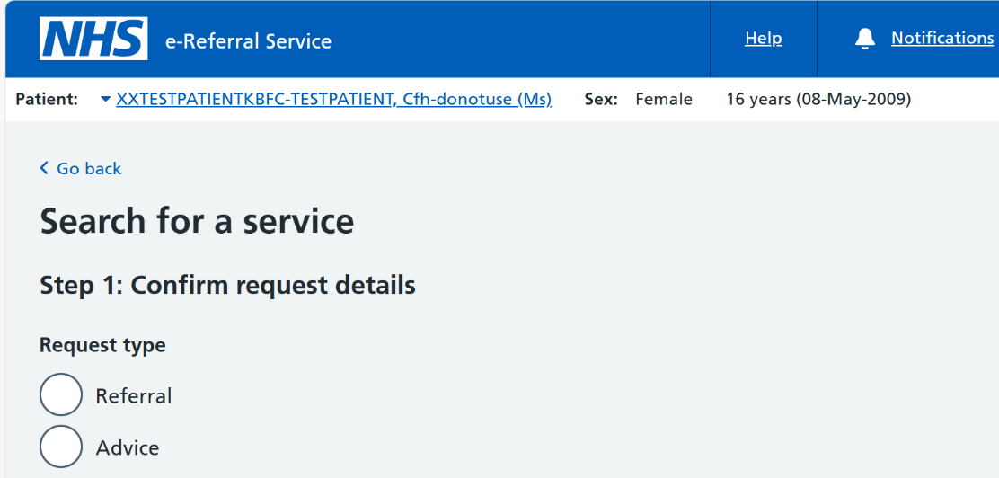

- The SPoA advice and refer option for your chosen specialty will appear on the list of services available. (see table below)
Specialty | SPoA Advice/Referral Service on eRS
Gastroenterology | Gastroenterology Diagnostic Coeliac Advice/Referral Service - LRI - RWE
Gastroenterology | Gastroenterology Advice/Referral Service - LRI - RWE
Hepatology | Hepatology Advice/Referral Service - LRI - RWE
HPB exc gallstones | Hepato-Biliary (HPB) Advice/Referral Service - LGH - RWE

- Please do not refer to the “nearest appropriate” specialty – as that will result in the referral being returned and will delay patient care
- Important - Please ensure you authorise the conversion to appointment for those patients who may need to be seen in clinic or for diagnostics, without this secondary care cannot covert to referral (see figure 2)

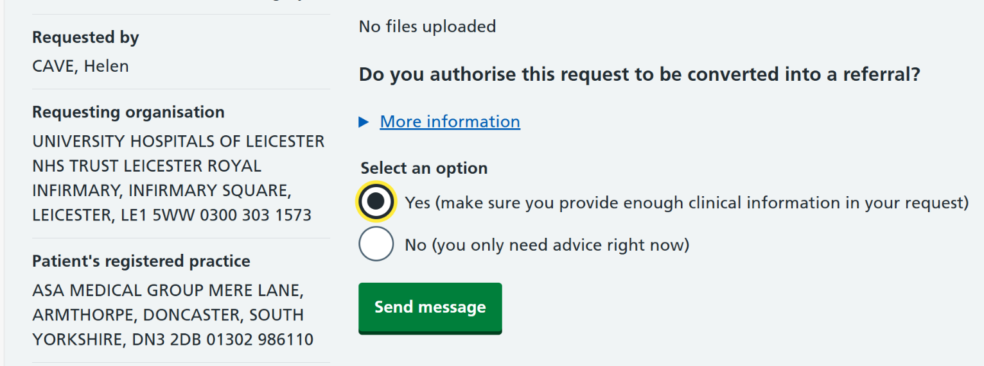
Figure 2

Note: Prism forms will remain unchanged
- Referral required: complete the relevant PRISM form or provide sufficient information in a letter to support a referral.
- Advice only: Continue to use the A&G form on Prism or free text in the advice request on e-RS with or without additional attachments.
- The administration section on PRISM has been updated to reflect this guidance including the e-RS SPOA advice/refer service name

Note: If you send an Advice & Refer request to the wrong Specialty/Service, secondary care will not have the functionality to redirect it via e-RS. Any such requests will be returned with advice, for corrective action to be taken by primary care.

Responses: Look for responses in your “Active advice requests” worklists on e-RS (rather than Triage responses / Rejected referrals worklist).

Specialty-Specific Notes
- HPB: Gallstones with pain (USS-confirmed) – continue as direct referral via eRS to:
    - Request Type – Refer, Speciality : GI and Liver, Clinic Type : Gallstones
All other HPB advice/referrals – via SPoA (Hepato-Biliary (HPB) Advice/Referral Service - LGH – RWE)
- Urgent Suspected Cancer (2WW): No change to current referral routes

Support and Feedback
SPoA is a nationally mandated requirement, and this pilot will help shape future rollout.
- A dedicated email inbox has been set up for feedback and queries during this pilot, please use this email for any issues, queries or general feedback. This will be in place during Q1 26-27
- Contact: llricb-wl.spoafeedback@nhs.net
For more information on the National Elective Care programme plans for implementing SPoA, please see the attached overview

