Prescibing Lead:

Aims of Policy:

* To standardise repeat prescribing processes and protocols within general practice
* To enable staff to understand their roles and responsibilities around repeat prescribing
* To provide guidance on good repeat prescribing process and procedures
* To ensure safeguards are in place to minimise error and reduce risk

Introduction:

Definition of a Repeat Prescription

‘A prescription issued without consultation’, whether the consultation is face to face or via the chemist

The production of repeat prescriptions is a team approach with input not only from the prescriber, but also from other members of the healthcare team to produce high standards of practice and care.

Methods of Requesting a Repeat Prescription

* The patient will be given a list of drugs they are currently taking on repeat prescription as a computer-generated list (the right hand side of the prescription slip)
* Use of the prescription request slip is preferred for non-internet requests and should be promoted by receptionists at all times.
* For most patients, a request for a repeat prescription should be made by the patient themselves or their carer.
* The patient will be encouraged to indicate on the repeat request slip which drugs they require when a request is made. If the form has been left blank and it is not obvious which medication is needed, the patient should be contacted to clarify
* Requests can be made:

1. Written request either using request slip or a letter, handed in directly to the surgery
2. By post
3. By fax
4. By internet using the website or by e-mail

* Telephone requests will not be accepted unless the Prescriber considers it to be safe or appropriate to do so. In such cases the prescriber should speak to the patient and decide if it is appropriate.
* Third party ordering has set restrictions (see Third Party Ordering)
* Patients should give 72 hours*’* notice when ordering repeat prescriptions. No prescriptions are issued at weekends or on bank holidays. In a normal week, prescriptions ordered on a Friday will be ready on a Wednesday.
* If a patient requests medication urgently (if appropriate this will be available later the same day)it should be checked with a prescriber before being issued. If a patient consistently requests medication late when they have “run out” of tablets, this should be brought to the Practice Manager’s attention.
* If a request for a repeat is from a recent hospital admission the practices medicines reconciliation policy should be followed. See medicines reconciliation policy.

There are six main stages in the repeat prescribing process:

Stage 1: Authorisation

Stage 2: Production of a prescription

Stage 3: Review

Stage 4: Compliance Check

Stage 5: Signing of prescriptions

Stage 6: Collection

**Stage 1 – Authorisation**

Authorisation is the decision by a prescriber that a particular medication is suitable to be obtained on repeat prescription for a particular patient. The prescriber should be satisfied that the patient is stable on the medication and that the medicine is well tolerated and still needed.

Only prescriptions which have been authorised may be issued by non-clinical members of staff. Authorised medication only includes medicines on “repeat templates” on SystmOne. It does not include medication that appears in for example the following sections of the patient medication record:

* Acute/ Current (‘medication’ on SystmOne)
* Past History

Repeat prescribing is justifiable and allows prescriptions to be managed but should be limited to medicines which are prescribed for long term therapy to patients who are stable.

Medicines that are subject to monitoring and dose titration (e.g. some new medicines following discharge from hospital) can be added to the repeat template with a short review date or limited quantity to be entered to ensure they are flagged up for review a early.

Antibiotics, antifungals and antivirals should not be added to repeat, unless in exceptional circumstances e.g. cystic fibrosis patients.

Careful consideration should be taken on the following classes of medicines as to whether they should be put on repeat to ensure appropriate follow-up:

* Antidepressants – if stable
* Antipsychotics – if stable and regular checks being done
* Anti-mania medication – if stable and regular checks being done
* Hypnotics – ideally this should not be prescribed. However there are circumstances where it is not possible to stop these medications so this could be considered carefully.
* Benzodiazepines – as above.
* Anxiolytics – as above.
* Controlled drugs (Schedule 2 or 3) – stable and no concerns about possible abuse.

System access rights for non-clinical staff should only allow prescriptions to be generated for items appearing on the repeat list. They may, however, have ‘read-only’ access to the other sections.

Number of days supply:

Each repeat item should be for 28 days as per local CCG guidance. This ensures that the patient can request all their medication together minimising wastage due to mismatched schedules. (It may not be possible to prescribe certain items for a common number of days – e.g. special containers, ‘when required’ items, the contraceptive pill and HRT. If it is appropriate for the patient, it is preferable to issue whole pack sizes (sometimes 30) rather than 28 days as this avoids wastage and broken packs.

Generic prescribing:

The practice has an agreed policy to prescribe generically unless agreed where brand prescribing is needed for safety or cost effectiveness, in which case it is in the SystmOne drug formulary as the agreed choice. Appendix B lists some medicines unsuitable for generic prescribing.

**Stage 2 – Production of Prescription**

Repeat requests

Repeat requests should ideally be received in writing on the repeat slip/counterfoil or online, as they are more likely to be processed accurately.

Requests received on repeat slips:

* + minimise transcription errors
  + minimise confusion with brand and proprietary name pronunciation
  + avoid matching the request to the patient’s record
  + allows prescriptions to be processed with no interruption from further calls

This practice accepts requests electronically via the website. Staff check for repeat requests at regular intervals. The repeat prescribing request should not be processed without all the relevant information highlighted below.

This practice does not accept telephone prescription requests except in exceptional circumstances when administrative staff should ensure they ask sufficient questions to process the repeat request accurately.

The questions asked via the telephone should cover ALL the following information:

* Patient’s Full Name
* Date of Birth
* Address
* Telephone Number (on which to be contacted should the prescriber refuse to issue the request).
* Medication Requested:
  + Name
  + Strength
  + Form
  + Dosage Instructions

If the patient forgets/ loses the repeat slip then a repeat slip can be printed from the patient’s medication record or alternatively a request slip could be completed by the patient.

Early requests for items are permitted in certain circumstances ie if a patient is due to go on holiday; any query re legitimacy should be brought to the doctor’s attention verbally asap if urgent or via paper tag if for within 72hrs.

Repeat prescriptions should be prepared with accuracy by a receptionist who is trained in the role of repeat prescribing

All personnel involved in the repeat prescribing process need to be sufficiently trained and have read and understood the practice repeat prescribing policy.

A computer system should be used to issue all prescriptions

All prescriptions should be generated by computer (see exception below)

Computers

* warn of possible interactions, contra-indications and side effects.
* are used as a source of data and audit to improve prescribing quality and maximise cost effectiveness.
* provide the doctor with a profile of their prescribing habits.
* provide the patient with a copy of the items that have been authorised as a repeat prescription, which can be used to request a repeat.

Home visits

A blank prescription can be taken from the locked area for prescriptions. Drug details are entered on return to the surgery as you would normally with issuing a prescription but the ‘Do not print them’ should pe pressed so no actual script is issued. These details must be added to the patient’s record as soon as possible, since this ensures an accurate record and allows for a double check on an contraindications or drug interactions.

Prescriptions that are issued by other prescribers eg hospitals need to be verified and then added to the patients repeat screen. This again allows for the flagging of important interactions especially with medicines such as warfarin, TB medicines and transplant medicines. Please see Medicines Reconciliation Protocol for further information.

Time to generate repeat prescriptions should be less than 72 hours

Sufficient time should be allowed for accurate production, checking and signing before collection by the patient. The patient should be informed of the turnover time (no more than 72 hours) in order to leave adequate time to order a repeat prescription when their medication is running low. This information is included in the Ratby Surgery patient information booklet produced by the practice.

Appropriately qualified members of staff

Tasks must only be carried out by appropriately qualified members of staff. Where a clinical judgement needs to be made (e.g. queries, amendment of review date, re-authorisation, review of hospital discharge) these must be performed by a qualified prescriber who is acting within their area of competence. Alternatively, another appropriately qualified clinical member of staff, e.g. a practice pharmacist, may undertake this role although at present there are none of these staff at the practice.

Processing a Request for a Repeat Prescription

**On-line**

Via SystmOne patient access

Patient communicates request to surgery

**In Writing**

Use either repeat slip or complete pro forma in full (patient may complete

pro forma themselves if able)

Check the patient’s name, address and date of birth against the computer screen record

**Via Telephone (exceptional)**

Ensure all questions are asked

on telephone checklist

Check that the items requested are on the patients repeat list.

If the patient requests any items not on the repeat list, refer to the GP

If the item appears on the repeat list, check that name, form, strength and dosage instructions are identical to the request

Send the prescription request through electronically to the ‘doctors’ tasks with the details as to why it hasn’t been issued for them to act upon.

If there are discrepancies refer to GP.

If dosage instructions are missing they must be inserted by the GP.

Check medication review date has not been exceeded.

If past review date refer to GP.

Check compliance to ensure patient is not under/over-using medication.

*NOTE: S1 will NOT always warn you*

If patient is under/over-using medication refer to GP.

Issue item on request

The name, address and date of birth must be checked with the person collecting the repeat prescription to confirm the identity of the patient.

Place prescription into pile A: ‘requests with no queries’ and leave for GP to sign

**Stage 3 – Review**

Review Dates

* All medications on a repeat template should have a maximum number of issues.
* The number of maximum issues for stable medications will be 12 months. It should be same for all medications on the template. However, it may be different for certain medications e.g. antidepressants or DMARDs etc.

Informing the patient that they need to make a review appointment

When a patient requests a repeat prescription, the receptionist should check that the repeat item(s) is/are within the authorised period.

*i.e.* the review date has not been exceeded

OR the number of authorised prescriptions has not been exceeded

If the review date is approaching, the item(s) can be issued and the patient informed that a review appointment is due by either putting a note on the script and/or informing the chemist to let the patient know in case of delivered medications.

If the review date has been exceeded the prescription must NOT be issued by the receptionist; it should be brought to the doctor/pharmacist’s attention as an acute medication task.

For doctors: When you receive the acute medication task

1. Check if the patient has recently been seen e.g. by the nurse for a chronic disease review. If you feel that the review can be done without seeing the patient then use the medication review template and update the medications
2. If patient has not been seen recently or there are medications e.g. painkillers etc that have not been covered by chronic disease review, then send a task back to reception to arrange a medication review. At the review update the template and review dates.

If possible timing the medications to patients annual disease review, bloods etc so this could minimise patients having to repeatedly attend would be optimal.

Length of review period:

The default for review period or maximum issues is 12 months, but it can vary dependent on the disease state or medicine being reviewed. These should ‘tie in’ with their annual disease bloods and reviews. Review periods should be stated individuallywith none being left longer than a year.

At review

During a review patients should be considered individually, with respect to their illness and medication.

The medication review template should be used.

The person reviewing the patient must be satisfied that the patient still requires long term medication and will check:

1. which medicines are being taken
2. whether the medication is at a stable dose

(ii) whether the medication is achieving the desired effect

(iii) whether the patient is experiencing any intolerable side effects

(Side-effects/ ADRs/ allergies should be recorded in the patient’s notes.)

(iv) whether the medication is still appropriate and at an appropriate dose.

(v) whether the patient understands the purpose of the medication

(vi) that the patient is able to take the medication

(vii) that it is the most suitable medicine and there is no better alternative

(viii) any medicines which are not being ordered and duplicate medicines, ensuring they are deleted from the patients’ medication record.

(ix) that the patient is not abusing their medication

(x) that any necessary tests have been carried out at appropriate intervals e.g. TFTs, DMARDs monitoring

(xi) the dosage instructions are clearly written on the prescription. If the prescription states ‘when required’ then a maximum dose needs to be stated.

(xii) that all medication is prescribed in equivalent quantities. The quantities must be sufficient and not excessive.

(xiii) that prescribing is generic where appropriate

(xiv) all other medications prescribed (including those from other organisations) and over the counter medicines are identified

(xv) that the patient is informed of the next review date

(xvi) that patients recalls and QOF are up-to-date.

**Stage 4 – Systems for checking compliance**

The computer system should provide a method of checking the patient’s compliance. SystmOne show a red/amber/green flag for each medication which, if the quantity and duration of issue are correct, will give a compliance indication. Also and ‘empty tablet bottle’ icon is displayed when a repeat has not been issued – see below where he simvastatin has not been issued for 40 days even though it should have been every 7 days.

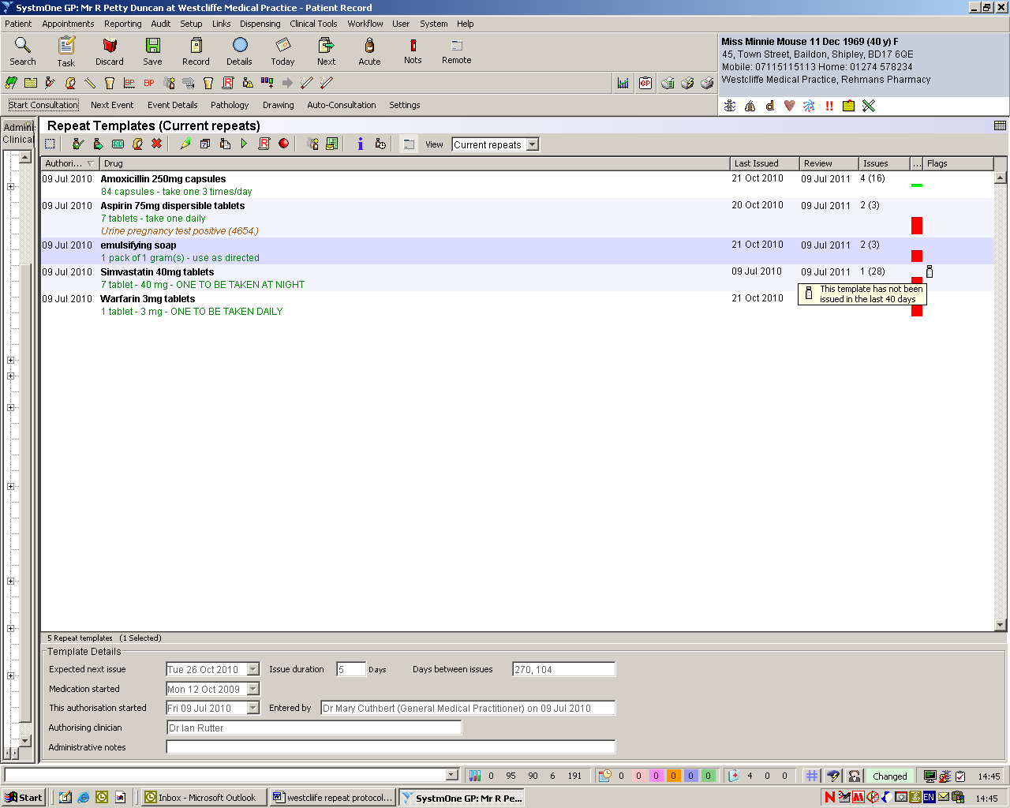

The importance of checking compliance should be emphasised to staff processing requests for repeat prescriptions, highlighting the importance of both under and over use.

The way in which the computer indicates compliance must be understood by all the receptionists processing repeat prescriptions.

When under/ over-use for a particular patient is shown as red on SystmOne for a medication then it should be referred to the prescriber.

Early requests for items should be permitted in certain circumstances ie if a patient is due to go on holiday, even though the computer will identify this as overuse. Please check with a doctor before issuing by sending a task.

Medicines which can be taken on a ‘when required’ basis may be flagged by the computer as being underused e.g. pain-relief, indigestion remedies etc. Staff who process repeat prescriptions should be aware that this is acceptable although should still be brought to the doctors attention.

**Stage 5 – Signing repeat prescriptions**

Prescribers have an allocated and protected time set aside each day for signing / reviewing repeat prescriptions. This need not necessarily be at the same time each day.

The prescriber must have access to the patients’ medical notes when signing / reauthorising repeat prescriptions.

**Stage 6 – Collection**

Staff handing over prescriptions must ensure appropriate identification has been checked - name and address / date of birth for example

Uncollected/ returned prescriptions

* Any prescriptions not collected after one month from the date of issue must be reviewed and the issue marked as not collected on the computer recordswhere appropriate.
* Any prescriptions not collected one month after the issue date, should be shredded after their issue has been removed from the computer screen.
* If it is not possible to cancel the last issue, the serial numbers should be recorded on the patient records, and a comment to the effect that the prescription was not collected. Then the prescription should be shredded
* Prescriptions returned by community pharmacists that have not been dispensed will be handled in the same way.

Security of Prescriptions Forms

* A register should be maintained detailing information about prescriptions: ordered, received, taken for use, and returned e.g. by GP locum etc.
* All blank prescriptions must be logged on the prescription tracking form as soon as they are received by the senior receptionist or, in their absence, the practice manager. The first and last serial number of each batch should be recorded.
* All prescriptions must be stored in a safe and secure manner. Blank prescriptions not in use must be kept in a locked cupboard.
* Stock levels must be kept at an acceptable level in line with safe storage facilities.
* When a delivery of blank prescriptions is made to the practice the cipher number on the outer box must match the cipher number on the prescriptions. This number should be one of the cipher numbers used by the practice.
* This procedure should also be followed when prescriptions are taken from storage for use in the surgeries, Doctor bags or by locums.
* Forms should not be left unattended at any time in the practice or in a car
* A limited number of forms should be taken for home visits/ use outside the practice.
* Internal surgery doors should be kept locked overnight
* Under no circumstances should a box of signed prescriptions be handed to any person who is not a member of practice staff to find a prescription.
* Measures should be taken to determine the identity of a representative collecting a prescription on a patient’s behalf and particularly in the case of controlled drug prescriptions, must be signed for.
* A risk assessment of prescription security should be carried out on a regular basis to ensure appropriate systems are in place.
* If a prescription is lost adequate steps must be taken to locate it. A note should be made in the patient records and practice incident book. If a prescriber authorises a re-issue the new prescription should be marked as ‘duplicate’.
* Patients who have lost or had stolen, prescriptions for medication liable to abuse must have notified the police and be in possession of an ‘incident number’ before a further prescription can be issued. This needs to be recorded in the patient’s notes.

**Miscellaneous**

Hospital discharge and home visits

Hospital letters and discharge medication notes are scanned on the day of arrival and sent to the local Federation Workflow Team to be reviewed. They are then forwarded onto a GP if there has been medication changes. They are sent to the relevant GP electronically in the ‘documents to process’ area for review. Any letters requiring same day action are placed onto the blue board for the oncall doctor.

Hospital formularies are often very different from a practice formulary and medicines may be temporarily substituted whilst in hospital and not changed back once the patient is discharged, or a medicine may be initiated in hospital that has cheaper alternatives in the community which are equally effective.

Evidence should be sought:

* whether the medicine is intended to be repeated
* that there is no unintentional duplication of existing medication
* that medication has not been stopped by the hospital in error
* what is the responsibility of the hospital and what of the practice in the prescribing and monitoring of a drug.

Shared care drugs

For medicines of a more specialist nature, shared care arrangements must be provided by the specialists before the GP can prescribe e.g. DMARDs, transplant drugs. The shared care protocol defines who takes responsibility for diagnosis, monitoring and prescribing and under what circumstances responsibility for prescribing should be handed back to the specialist. See separate policy for DMARDs.

So called ‘red drugs’, or ‘hospital only’, are drugs that should not be prescribed in primary care. These include items such as chemotherapy and drugs being used out of license e.g. sildenafil for Crest syndrome or primary pulmonary hypertension. By signing the prescription the prescriber assumes legal responsibility and therefore must be satisfied that he/she has the necessary clinical knowledge and skills before taking on the prescribing of any medicine. Red drugs may be added to the repeat template for information only as a single tablet with clear documentation ‘for information only’.

Special products

“Specials” is a term applied to a group of medicines that do not have product licenses. They are usually very expensive and require the community pharmacist to order the product in specially. They are often listed on the practice computers but characteristically they have no price listed against them.

“Non Multilex drugs” are drugs not on the GP computer system’s pick list of medicines. Prescribers can create non-multilex additions to the prescribing system but this would be in exceptional circumstances. If it does not appear on the list there is probably a good reason. In this situation seek advice from clinical pharmacy support.

There are five main reasons why GPs should not prescribe a special without being fully aware and having considered alternatives.

* The product may not have a product license and therefore the prescriber is liable for the product quality.
* The medicine is often very expensive e.g. calcium carbonate liquid special 120mg/5ml can cost £1,236 per item.
* The supply is not guaranteed and the patient may have periods without treatment.
* It causes significant inconvenience for the community pharmacist to obtain the supply.
* Some specials are not listed on GP systems and have to be entered as non-multilex drugs. Consequently drug interactions/cautions etc are not highlighted e.g. methotrexate special and penicillin.

Before prescribing a special ask the following questions.

1. Is there a valid indication? There may have once been a valid indication but the patient may no longer be likely to be benefit
2. Is the medicine reasonable to be prescribed by a non-specialist? The medicine may be appropriate for the patient but of a specialist nature.
3. Can the patient really not swallow solid dosage forms?
4. Is there a licensed equivalent? Use the BNF or the Drug Tariff to identify if there is another product that you can use as an alternative.
5. Is there a less expensive special? If a liquid must be used and there is no licensed alterative then consider a special that is less expensive. Ask clinical pharmacy support for advice.

Explaining the process to patients

When a patient is initiated on repeat medication the process for ordering should be explained to the patient and an information leaflet offered. This leaflet can be found on the practice website. There are also instructions on the repeat items print out.

Nursing and residential homes and monitored-dosage system requests

There is an allocated GP for each care home to improve continuity of care. Repeat prescribing is monitored according to practice protocol.

Repeat Dispensing

Repeat Dispensing allows pharmacies to manage and dispense repeatable NHS prescriptions in instalments for medicines and appliances, in partnership with the patient and the prescriber. The pharmacist ascertains the patient's need for a repeat supply and communicates any clinically significant issues to the prescriber. The aim of the service is to increase patient choice and convenience, to minimise wastage, to reduce the workload of General Medical Practices and to enable pharmacies to manage their workload.

The patient is given a repeatable prescription plus a number of batch issues (up to 12) which are usually held in the pharmacy. Once the Electronic Prescription Service is established the batch issues will be stored electronically on the NHS spine and accessed up to 7 days before a repeat is required. This is more suitable to those patients who are not having repeated medication changes.

Dossett box and repeat dispensing.

For changes to repeat items for patient receiving a dossett:

1. It is the doctor’s responsibility to make the appropriate change on S1 repeat items.
2. Doctors should communicate directly with admin or the pharmacist if changes are required immediately.
3. Administration members or the GP will directly call the pharmacist to inform them of the changes. Admin issue and print any repeat items to bring the changes in line with current repeats.

Repeat Medication Services

Nomination is a new process that gives patients the option to choose or nominate a dispensing contractor to which their prescriptions can be sent automatically through the Electronic Prescription Service. There is specific legislation which governs nomination for EPS.

It states that GPs must not seek to persuade a patient to nominate a specific dispenser; and if asked by the patient to recommend a dispenser to nominate they must provide the patient with a list of all the dispensing contractors in the area who provide an EPS service. NHS choices (www.nhs.uk) can be used to provide details of which pharmacies are near to the patients home, surgery or place of work.

Third Party Ordering

West Leicestershire Clinical Commissioning Group (WLCCG) recently discussed and approved changes to third party ordering for some patients, this is where community and online pharmacies, are ordering repeats automatically on behalf of patients without necessarily checking with the patients that they need all the drugs on the repeat list.  This has resulted in patients across the county accumulating large stockpiles of drugs, and in some incidences taking medication on a regular basis which is only required for occasional use. Alongside this there has been an assumption medications have been taken when in actual fact they are being stored potentially putting patients in danger. In addition to these safety concerns it is extremely wasteful.  It has been estimated that nationally £90m worth of unused medicines are retained in patient's homes.

The CCG has asked for help by asking practices to no longer accept these repeat requests for the majority of patients, and instead for the patient/ carer to request the repeat order themselves, directly from the GP Practice

There are certain circumstances for example if you are on a Dossett box or deemed to be potentially vulnerable where this may not be unsuitable for you and you may be exempt e.g. severe dementia, dossett boxes etc.

Each case is discussed individually with the GPs to see if this is reasonable.