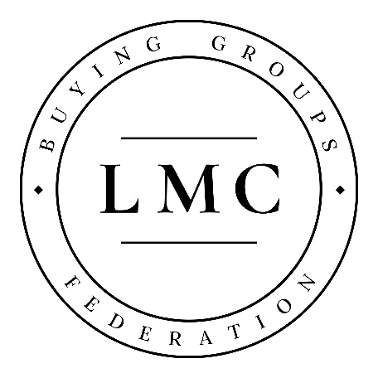
New Supplier: Royalty-free Music (AKM Music)

Our new supplier, AKM Music, can offer GP practices a much cheaper alternative to paying PPL and PRS licence fees every year.
They have a great selection of royalty-free music you can play in your waiting room or behind the scenes at your practice without ever having to pay any fees to PRS or PPL.
You simply select the music you like on their website, purchase either a CD or MP3 download and start playing. There are no annual renewal charges and each order comes with a certificate proving you no longer need to pay PRS or PPL.
To browse the range of non-PRS/PPL music visit AKM’s website.
LMC Buying Group Discount
Buying Group members qualify for 20% off the purchase of a single CD/album download and 30% off RRP when purchasing three or more CDs/album downloads (RRP = £30+VAT).
To ensure your Buying Group discount is applied, please ensure you use your practice’s main telephone number when filling out the form on the ‘checkout’ page of AKM’s website. If you notice that the discount has not been applied, please contact AKM Music.
Contact AKM Music

Tel: 01926 864068
Email: akm@akmmusic.co.uk
Web: http://www.akmmusic.co.uk/

New Supplier: Vacancy Advertising

With the increasing demands on the primary care sector, it is important that GP practices have the strongest platform to advertise their vacancies.
GP Jobs gives LMC Buying Group members the opportunity to connect with their monthly audience of over 8,000 primary care professionals seeking their next role, to provide a robust and effective recruitment solution – with an exclusive discount of up to 25% on job advertisements.
GP Jobs can proactively target the primary care audience using their range of traffic driving inventory, proven to bolster and increase application rates from relevant applicants.
With visual branding solutions, targeted email campaigns and careers content marketing solutions available, they can cater for each practice’s recruitment needs in a bespoke way, ensuring you get the best response possible based on your specific needs.
LMC BUYING GROUP PACKAGES
Package 1 – Targeted Package

- Premium Listing
- Editorial Job
- Targeted email
- Candidate email
- MPU
- Refresh
- Tweet

Rate card: £1,280
LMC BG rate: £960 (25% discount)
Package 2 – LMC BG Package

- Premium Listing
- Targeted Email
- Tweet

Rate card: £1,145
LMC BG rate: £915 (20% discount)
Package 3 – Express Package

- Premium Listing
- Editorial Job
- Tweet

Rate card: £780
LMC BG rate: £700 (10% discount)
When contacting GP Jobs, clearly state that your practice is a member of the LMC Buying Group in order to receive our discount.
Contact GP Jobs
Tel: 020 8267 4949
Email: jack.diamond@haymarket.com
Web: http://jobs.gponline.com/

New Supplier: Medeconomics/MIMS Subscriptions

Medeconomics is an essential GP business resource providing practical, accessible advice and information on all the important issues in practice management and finance.
The essential resource for general practice management, Medeconomics gives you:

- Access for up to 15 users with each practice subscription, so everyone in your business can answer their questions directly and you smooth out business communication
- Key financial and business information for general practice including the GP Fees Database, the Locum Rates Database and extensive guidance to all aspects of practice finance
- Support for managers and partners in running financially healthy and efficient practices to deliver the best possible patient care.

Buy online to take advantage of your special LMC Buying Group rate (20% discount).

MIMS Learning offers a simple, intuitive way to organise, undertake and export your learning with content and learning plans tailored to your education needs.
Essentials is an online learning programme covering the most important and latest guidance for GPs, by GPs. Based on key updates to NICE and other guidance, Essentials enables GPs to directly improve patient care while earning up to 50 CPD points of online learning – plus they can export notes directly to the Clarity and RCGP Appraisal Toolkit for GPs with one click.
Members can save 20% on a MIMS subscription. To access your special LMC Buying Group rate, email Alice French with your practice information and number of users required.

