How To: Record the outcome for a COVID-19 Medical Exemption Application following clinical assessment

- Launch the NHS Spine Portal via your Desktop shortcut or through your web browser
https://portal.national.ncrs.nhs.uk/portal/
N.B. Microsoft Internet Explorer is no longer supported

- Ensure you are logged in with your Smartcard – You cannot access the portal without it.
Click on Launch Summary Care Record (SCR)
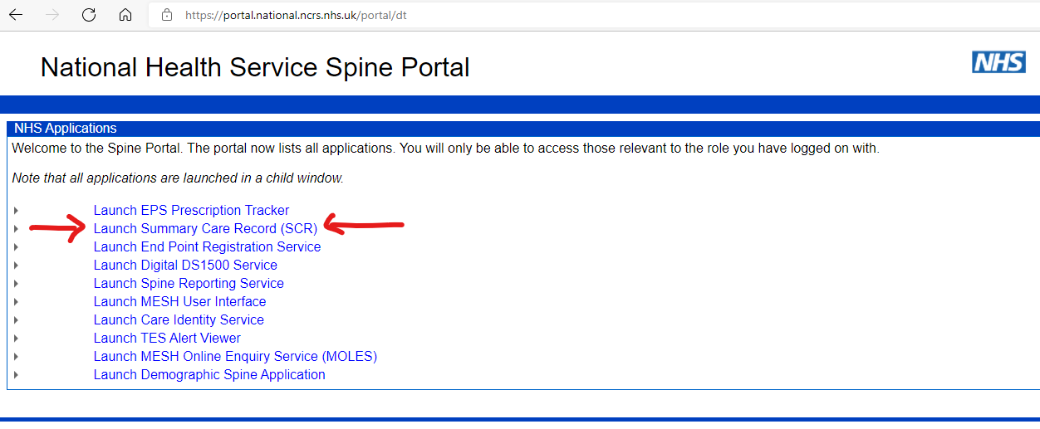
Your Smartcard must have Patient trace (B0264) access rights. If you do not have the correct permissions, you will not be able to proceed further – please speak to IT.

- Search for the patient whose application form you are processing by entering their NHS number and clicking on Find

- Check the demographic details of the patient displayed in SCRa match those on the application form and your local clinical system

- Click on the COVID-19 Exemptions tab, then click Record a COVID-19 exemption application outcome
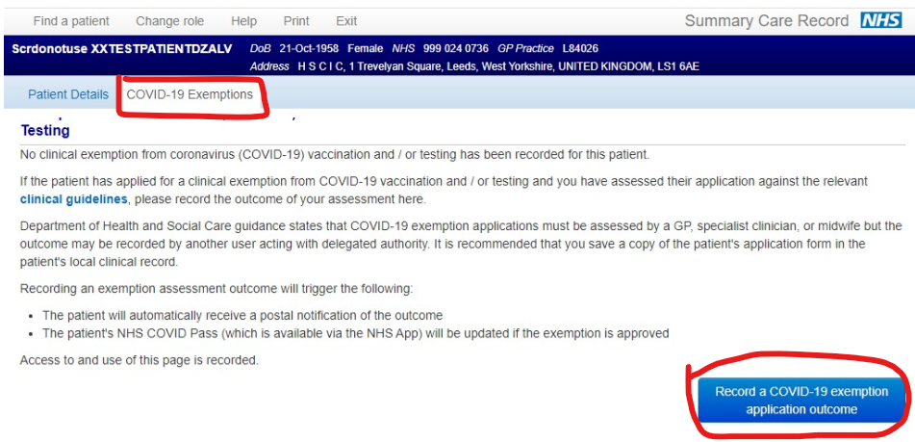

- Select the outcome from the list of options, then click Record a COVID-19 exemption application outcome to save your entry
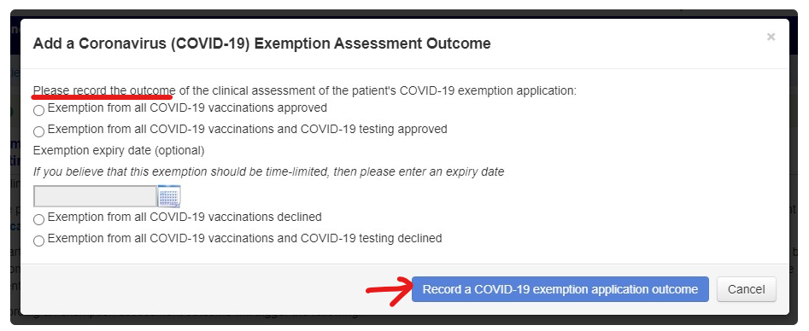

- A green banner will confirm that the outcome had been successfully added and details of the outcome will be displayed below
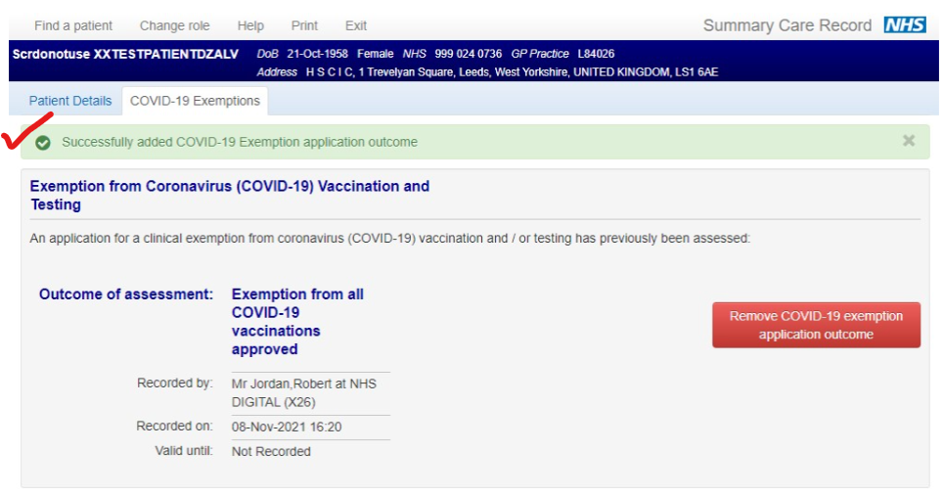

- Exit the Shared Care Record

For the latest information, visit
https://digital.nhs.uk/services/summary-care-record-application/covid-pass-medical-exemption

