# BMA Subject Access Request Survey

GPs were contacted via email to fill in an online survey on behalf of their practice on their experience with subject access requests and changes since the introduction of the General Data Protection Regulation (GDPR)

* The survey was open between the 5th and 30th of September 2018
* The survey received 1,571 complete responses

## Change in average number of Subject Access Requests (SARs)

Average number of requests per month in year prior to the introduction of GDPR: **8.57**

Average number of requests per month in the last full calendar month: **11.68**

Change in numbers of SARs implied by this survey: **36%** or just over 3 requests a month on average.

## On average, how long in minutes does it take in total to complete one subject access request?

Just over **74** Minutes on average, but the majority of respondents completed requests in 60 minutes or less

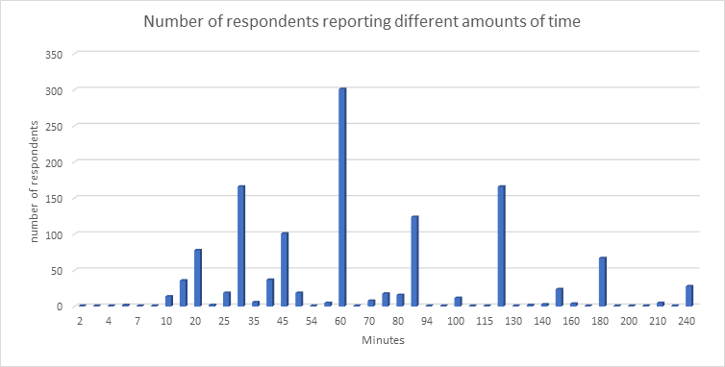

## On average, what percentage of SARs work is carried out by the following methods?

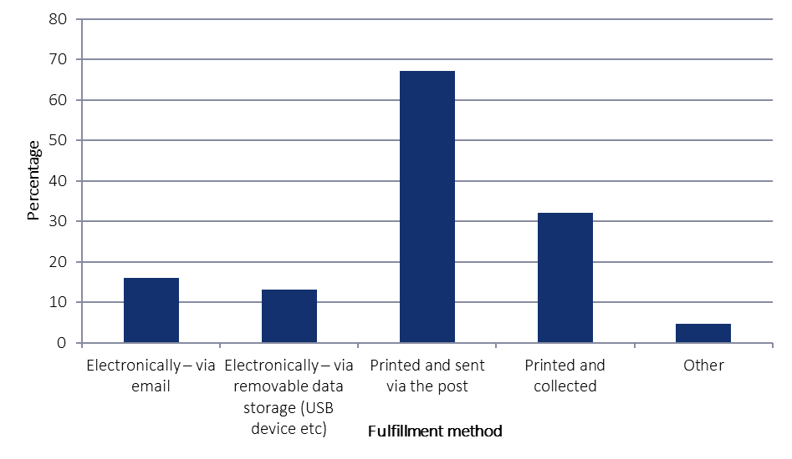

NB: The ‘other’ category included respondents who allowed access to an online portal to view patient records and delivery in person.

## On average, what percentage of SARs requests came from the following sources?

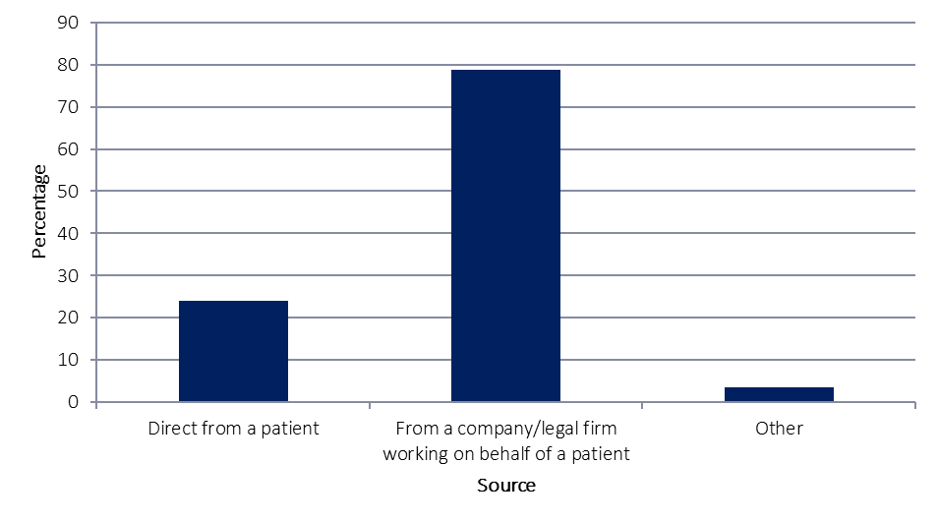

NB: The ‘other’ category included requests from the army, police forces, courts, local authorities, insurance companies and the prison service.